# Run Visual Studio 2015

1. From top menu select *Team -> Connect to Team Foundation Server…*

*Team Explorer – Connect* window should appear.

1. Click on *Select Team Project*…

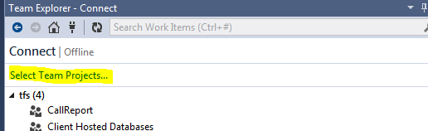

Similar window below should appear:

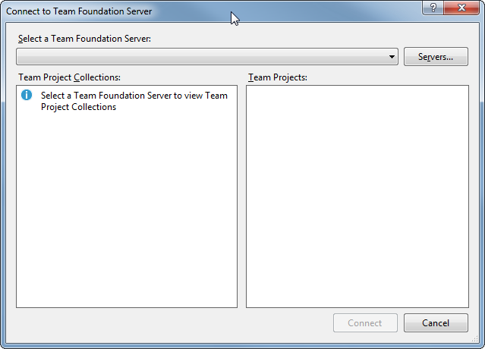

1. Click Servers button. In case you do not have <http://tfs:8080/tfs> added as TFS Server then press *Add* button and write *tfs.* Click *OK.*

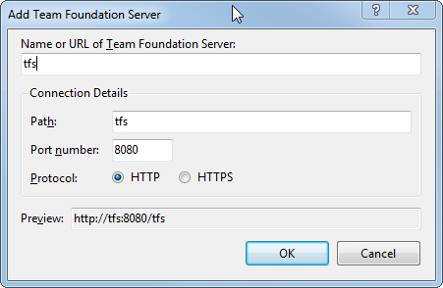

Server is added. Click Close.

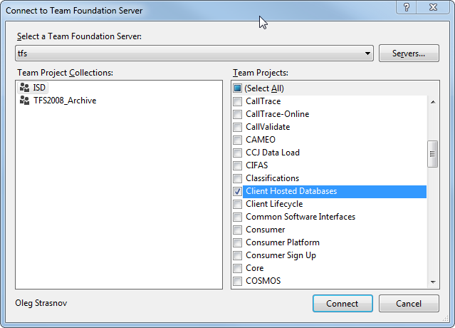

1. Select *ISD* on the left side and *Client Hosted Databases* on the right side. Click Connect.
2. In *Team Explorer – Home Window* (*View -> Team Explorer*) select *Source Control Explorer*

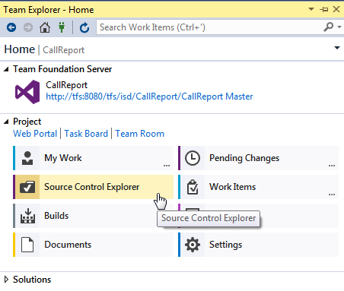

You should window similar to the picture below:

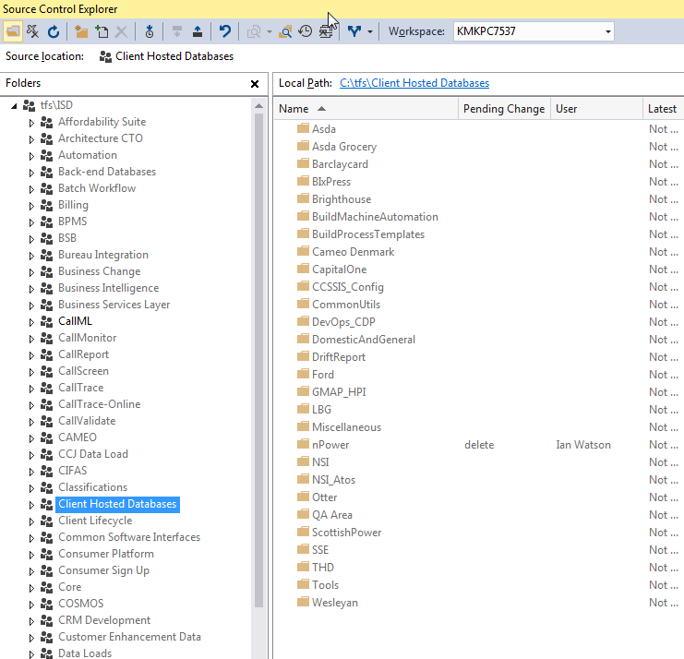

1. On the left-side expand *Client Hosted Databases -> QA Area -> 2 Trainings*
2. Right-click on a *SpecFlowDojo_DB* and click *Get Latest Version*

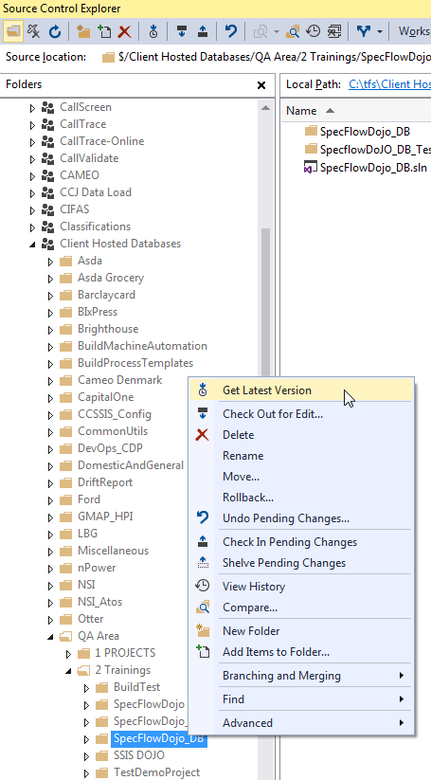

Wait till source will be downloaded locally.

1. Double click on *SpecFlowDojo_DB.sln*

Wait till Solution will be prepared. In *Solution Explorer* (*View -> Solution Explorer*) window you should see:

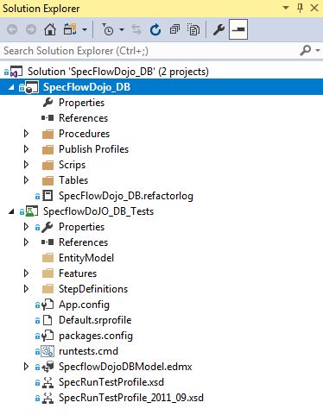

1. Open App.config file (double-click)

Find the string “**initial catalog=SpecFlowDojo_DB**” and change **SpecFlowDojo_DB** to a name provided to you.

1. Right-click on a Solution and select *Enable NuGet Package Restore*. Press *Yes* when dialog window will appear.

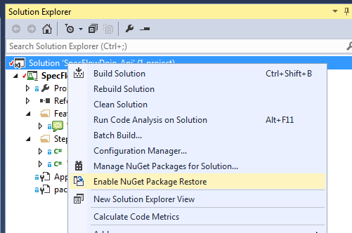

Click OK when you get dialog window as below:

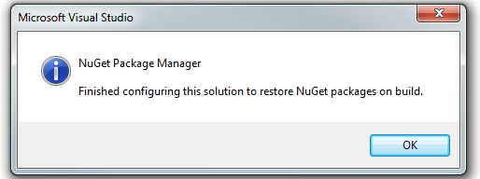

1. When it finishes right-click on a Solution again and select *Build Solution*. No errors should occur.

# Open existing tests

1. Open *Test Explorer* window (*Test -> Windows -> Test Explorer*)

You should see this window as below:

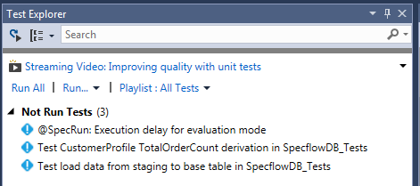

1. Right-click on any desired test (e.g. *PostcodeRegionAndDistrictByPostcodeOX495NU*) and select **Run Selected Tests**  
     
   Test should pass if all was OK.
2. You can click on Output link in the bottom to see the output from the future test

